

Predicting Telecom Churn using Machine Learning

Asma Alkarbi – H00492811

CDS 3633 Machine Learning for Business Analytics
Dr. Ameur Bensefia
Higher Colleges of Technology

Table of Contents
1. Customer Churn in Telecom Prediction Overview 3
1.1. Business Importance of Churn Prediction in Telecom 3
1.2. Previous Studies on Churn Prediction in Telecom 3
1.3. Project Objective 4
2. Telco Customer Dataset Description 4
2.1. About Dataset 4
2.2. Features Description 4
2.3. Target Variable 7
3. EDA 7
3.1. Summary Statistics 7
3.2. Data Quality Check 8
3.3. Churn Distribution Analysis 12
3.4. Churn by Different Features 12
3.4.1. Churn by Contract Type 12
3.4.2. Churn by Payment Method 13
3.4.3. Churn by Dependents 14
3.4.4. Churn by Tenure (in months) 14
3.5. Key Insights on Customer Churn 16
4. Data Preprocessing 17
4.1. Data Cleaning 17
4.2. Encoding 18
4.3. Correct Data Types 18
4.4. Feature Selection by Correlation 20
5. Modeling 20
6. Models Evaluation 22
6.1. Feature Importance 25
6.2. ROC AUC Curve 26
7. Churn Prediction Results 28
7.1. Best Model 28
8. Conclusion 28
8.1. Summary of Findings 28
8.2. Recommendations for Reducing Churn 29
8.3. Limitations 29
8.4. Future Improvements 30
10. References 31

Customer Churn in Telecom Prediction Overview

Business Importance of Churn Prediction in Telecom
Boddepalli (2024) says customer churn is a critical issue faced by telecommunication providers as it drives costs related to customer attraction to soaring high levels as opposed to keeping current customers from leaving. By correctly executing prediction of churn, said company can be proactive by implementing retention techniques.
According to Sam et al. (2024), As the telecommunications sector deals with many consumers, it generates enormous amounts of data daily. According to decision-makers and business analysts, the process of new client acquisition is more expensive than retaining the existing ones. Business analytics experts working in the field of business data and CRM must be aware of the reasons behind customer churn.
A study by Ribeiro et al. (2024) explores what causes churn among consumers, specifically subscribers who subscribe to packages offered by telcos. They collected data from a sample size of more than 3,000 telecom users. Internet, television, and positive customer service were discovered as key factors for customer retention, whereas landline telephony services didn’t contribute much in reducing churn. Also, they found that the more customer is loyal, it creates a negative correlation with churning.

Previous Studies on Churn Prediction in Telecom
In a study by Nie et al. (2011), they build a model aimed at predicting churn by using real credit card data obtained from a Chinese bank. Through their analysis, they apply feature selection by correlation and in the end, they conclude that logistic regression and decision tree have produced satisfactory results which meet their goals, also entailing that logistic regression performed better.
A paper by Chen et al. (2025), shows how they provide a detailed methodology for the prediction of customer churn within the telecommunication industry through deep neural networks. The methodology starts with a detailed definition of the problem statement, followed by data analysis and feature engineering, which enables the building of a model capable of detecting complex patterns in the behavior of potential churners. Finally, the model is thoroughly evaluated with multiple metrics, and it gives a strong and reliable performance.
In a paper by Krishna et al. (2024), they study customer retention and prevention of churning. They use Machine learning techniques such as random forests to analyze and classify client data who register or unsubscribe. The findings are compared with support vector machines, gradient boosting, XGBoost, and LightGBM techniques in machine learning. Developing these models will give decision-makers the opportunity to act and prevent churn and financial losses. The model manages to achieve a prediction of churn with an accuracy rate of 98.1% by using the random forest approach.

Project Objective
Objectives of the project will be aimed at developing models for predicting customer churn using machine learning techniques. The project will aim to analyze customer behavior and service usage patterns to identify top causes of customer churn. Moreover, practical suggestions will be made for addressing customer retention issues.

Telco Customer Dataset Description

About Dataset
The dataset of Telco Customer Churn obtained from Kaggle contains data about behavior of 7043 customers with a telecommunications provider. The dataset has 20 features and one target variable named Churn. For feature types, there are categorical and numerical (tenure, monthly charges) features. The mix of feature types helps to analyze clients behavior and service usage. Telco Customer Churn is qualified for performing a classification problem to forecast whether the customer will churn or not (BlastChar, 2017).

Features Description
Name | Type | Description | Example
customerID | Identifier | Customer’s unique ID | 7590-VHVEG
gender | Categorical | Gender of the customer. | “Female”, “Male”
SeniorCitizen | Numerical | Whether the customer is a senior citizen or not. 0 represent not a senior citizen. 1 represent a senior citizen | 0 or 1
Partner | Categorical | Whether the customer is married or not. Yes means married. No means unmarried. | Yes, No
Dependents | Categorical | Whether the customer is legally responsible for someone (e.g. children) or not. | Yes, No
tenure | Numerical | Number of months the customer has stayed with the telecom company. | Ranges from 0 to 72 months (or 0 to 6 years)
PhoneService | Categorical | Whether the customer is subscribed to a phone service or not. | Yes, No
MultipleLines | Categorical | Whether the customer has multiple phone numbers or not. Some don’t have a phone service to begin with. | No phone service, No, Yes
InternetService | Categorical | Whether the customer has an internet service or not. If yes, which type. Some don’t have an internet service at all. | No, DSL, Fiber optic
OnlineSecurity, OnlineBackup, DeviceProtection, TechSupport, StreamingTV, StreamingMovies | Categorical | All of these are internet-related services. Some choose to get them, some don’t, some don’t have an internet service to begin with. | No internet service, No, Yes
PaperlessBilling | Categorical | Whether the customer’s bill is received on paper or not. | Yes, No
PaymentMethod | Categorical | How the customer chooses to pay for services. Some payment methods are manually done, while others are automatic. | Electronic check, Mailed check, Bank transfer (automatic), Credit card (automatic)
MonthlyCharges | Numerical | Amount of money the customer pays the telecom company per month. This money goes into customer’s subscriptions and services. | Ranges from 18.25 to 118.75 per month. (currency unknown)
TotalCharges | Numerical | MonthlyCharges multiplied by tenure | Differs per person

Target Variable
The variable that is dependent in this dataset is Churn. It indicates whether a customer stopped using the services provided and stopped being the telecom’s company’s customer. This is a binary categorical variable, which can only take two forms which are “Yes” or “No.” Here, “Yes” represents the case where the customer churned, while “No” represents the opposite case. Thus, this is a binary classification task.

EDA

Summary Statistics
# rows and columns
print(f"Number of rows: {df.shape[0]}")
print(f"Number of columns: {df.shape[1]}")

Number of rows: 7043
Number of columns: 21
# descriptive statistics
df.describe(include='all')
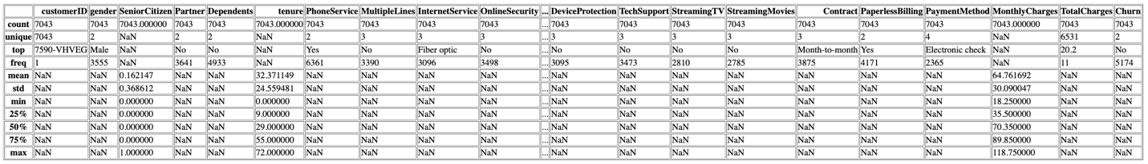

The dataset has 7043 observations with 20 features and 1 target, this dataset has a good enough size for building a model using machine learning. Among the features, we can see several categorical features, while some others are numerical, such as tenure, MonthlyCharges, and TotalCharges.
From the summary statistics, we can see that tenure varies between 0 and 72 months, with an average value of approximately 32 months, which means that we have both new and loyal customers in the dataset. The variance is high for monthly prices, as they range from 18 to 118.
However, it should be mentioned that TotalCharges includes missing or wrong data, thus, it contains less information compared to the rest of the variables. TotalCharges is also a derived column so, it was excluded due to bringing data quality issues for having strong correlations with its derived features, causing potential multicollinearity. In addition, several categorical features have categories such as No internet service or No phone service.
Nevertheless, the dataset seems to be good enough for modeling.

Data Quality Check
# dataferame showing data type, number of nulls, negatives, zeros, and unique values in each column
numeric_cols = df.select_dtypes(include=np.number).columns

summary_df = pd.DataFrame({
'Data Type': df.dtypes,
'Nulls': df.isnull().sum(),
'Negatives': (df[numeric_cols] < 0).sum().reindex(df.columns),
'Zeros': (df[numeric_cols] == 0).sum().reindex(df.columns),
'Unique Values': df.nunique()
})
summary_df
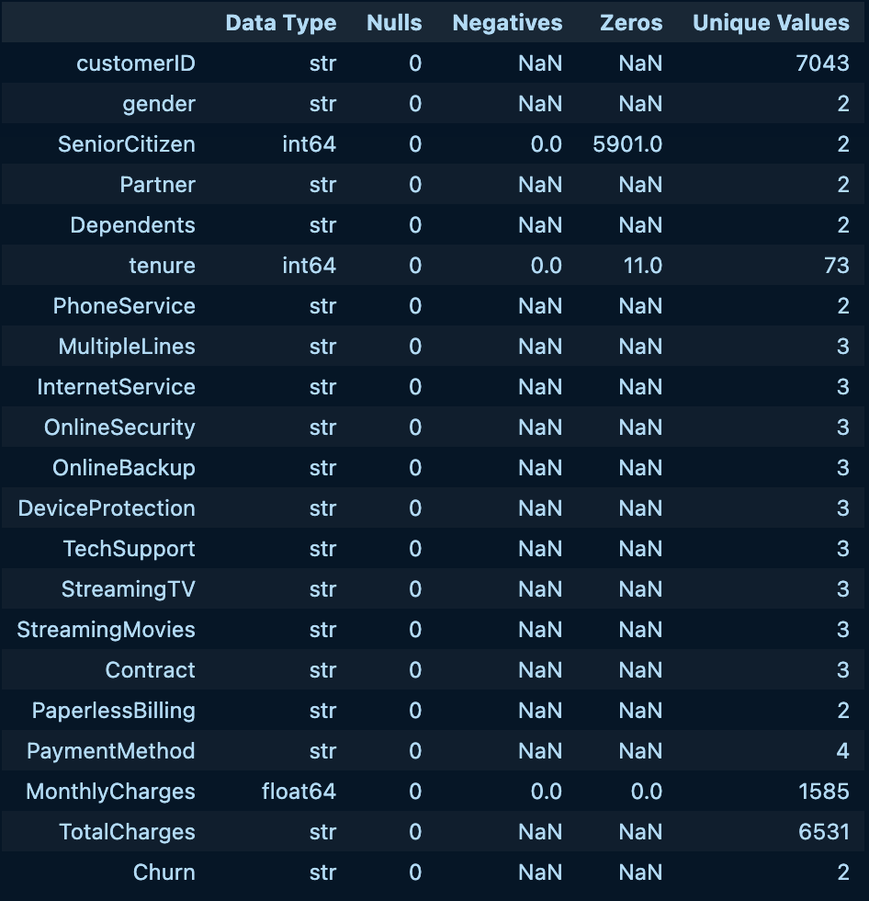

It is observed that there are no missing values for most of the features, which indicates completeness in the dataset. However, certain numeric features show high numbers of zero values, such as SeniorCitizen and tenure. These zeroes could be actual data and do not mean any mistakes.
In addition, the dataset contains both categorical and numeric data types, which implies that the categorical features need encoding for modeling.
Certain features contain only limited categories of values, such as gender or Partner, as they’re considered binary features. Other features include several categories, including InternetService and PaymentMethod.
It is also worth mentioning that the data type for TotalCharges is a string, despite total charges showing as a number. This discovery is telling of how important it is to conduct checks and remaining unbiased towards data.
Overall, the dataset is rather clean and will require feature transformations during pre-processing.

# display the unique values in each column excluding cusomterID and columns with more than 10 unique values
for col in df.columns:
if col != 'customerID' and df[col].nunique() <= 10:
print(f"Unique values in '{col}': {df[col].unique()}")

Unique values in 'gender': <StringArray>
['Female', 'Male']
Length: 2, dtype: str
Unique values in 'SeniorCitizen': [0 1]
Unique values in 'Partner': <StringArray>
['Yes', 'No']
Length: 2, dtype: str
Unique values in 'Dependents': <StringArray>
['No', 'Yes']
Length: 2, dtype: str
Unique values in 'PhoneService': <StringArray>
['No', 'Yes']
Length: 2, dtype: str
Unique values in 'MultipleLines': <StringArray>
['No phone service', 'No', 'Yes']
Length: 3, dtype: str
Unique values in 'InternetService': <StringArray>
['DSL', 'Fiber optic', 'No']
Length: 3, dtype: str
Unique values in 'OnlineSecurity': <StringArray>
['No', 'Yes', 'No internet service']
Length: 3, dtype: str
Unique values in 'OnlineBackup': <StringArray>
['Yes', 'No', 'No internet service']
Length: 3, dtype: str
Unique values in 'DeviceProtection': <StringArray>
['No', 'Yes', 'No internet service']
Length: 3, dtype: str
Unique values in 'TechSupport': <StringArray>
['No', 'Yes', 'No internet service']
Length: 3, dtype: str
Unique values in 'StreamingTV': <StringArray>
['No', 'Yes', 'No internet service']
Length: 3, dtype: str
Unique values in 'StreamingMovies': <StringArray>
['No', 'Yes', 'No internet service']
Length: 3, dtype: str
Unique values in 'Contract': <StringArray>
['Month-to-month', 'One year', 'Two year']
Length: 3, dtype: str
Unique values in 'PaperlessBilling': <StringArray>
['Yes', 'No']
Length: 2, dtype: str
Unique values in 'PaymentMethod': <StringArray>
[ 'Electronic check', 'Mailed check',
'Bank transfer (automatic)', 'Credit card (automatic)']
Length: 4, dtype: str
Unique values in 'Churn': <StringArray>
['No', 'Yes']
Length: 2, dtype: str

Majority of the features are categorical, with a minimal number of values per variable. Certain features like Gender, Partner, Dependents, SeniorCitizen, and Churn are binary variables with yes or no answers. As a result, such variables will be quite easy to encode during preprocessing.
On the other hand, features like Multiple Lines, Internet Service, Contract, and PaymentMethod have three or more options each.
Moreover, there are variables that have "No internet service" and "No phone service" values, which are special cases rather than regular categories, requiring special preprocessing.
It should be noted that “No” differs from “No phone/internet service” as they’re contextually contrasting. “No” refers to customers who actively choose not to subscribe to a certain service, while “No phone/internet service” means they never had a phone or internet service to begin with, thus not having the option to choose “No” or “Yes”.
Overall, encoding this dataset should be easy, while considering contextual differences.

Churn Distribution Analysis

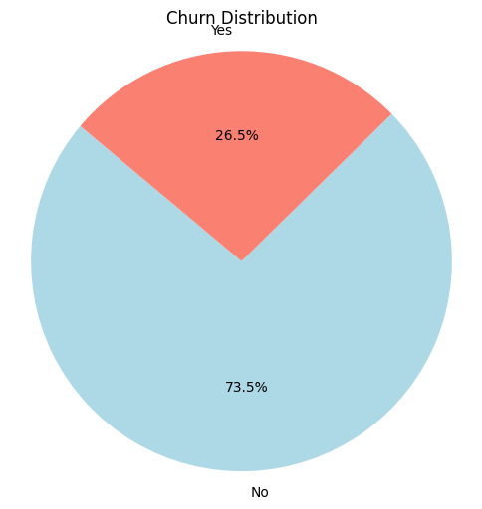

Churn in this dataset appears to be imbalanced. With a technique like SMOTE, synthetic data can be generated to counter the imbalance and improve model learning while avoiding bias.

Churn by Different Features

Churn by Contract Type
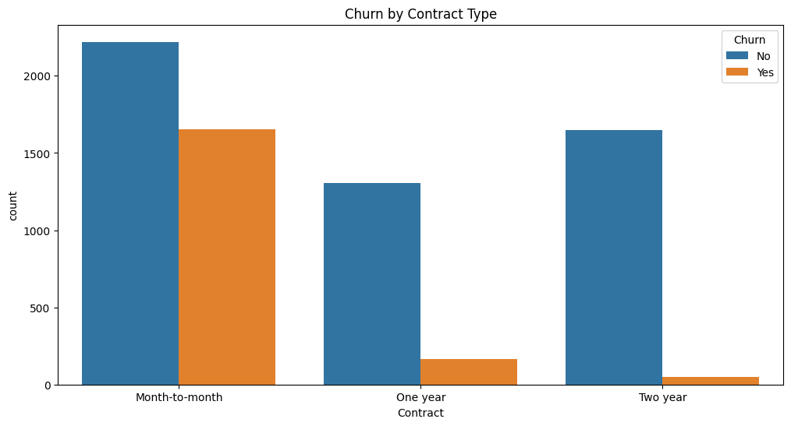
People with monthly contracts are more likely to churn, mainly because they don’t feel as restricted as those with longer contracts. Such customers need lucrative offers that’ll make them stay.

Churn by Payment Method
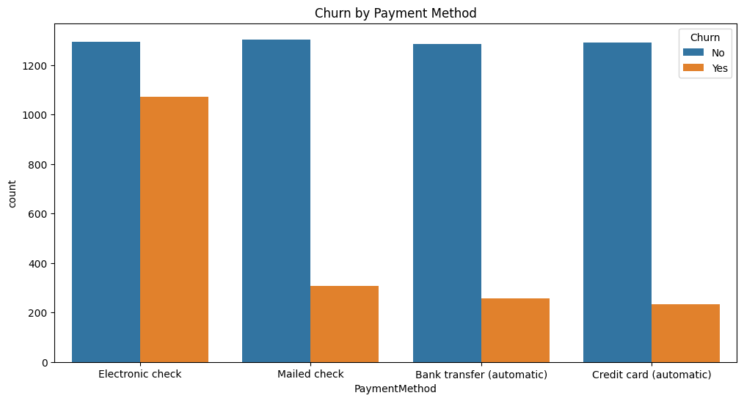
People using manual payment methods, mainly electronic checks, are more likely to churn than those using automatic payment. This could be because of the effort needed in making manual payments with checks or delaying payment causes disruptions in services which could drive them to churn. There’s less commitment without automatic payment.

Churn by Dependents
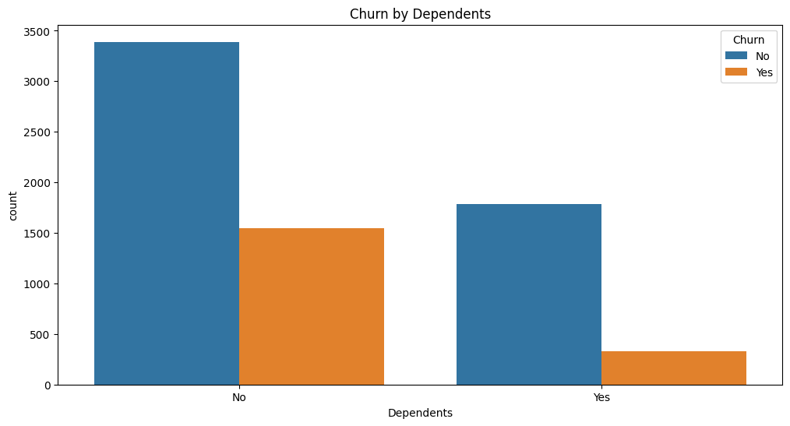
People without dependents tend to churn more. This is likely because they don’t carry as much commitment as those with dependents. People with dependents have greater responsibilities and choose to stay for stability.

Churn by Tenure (in months)
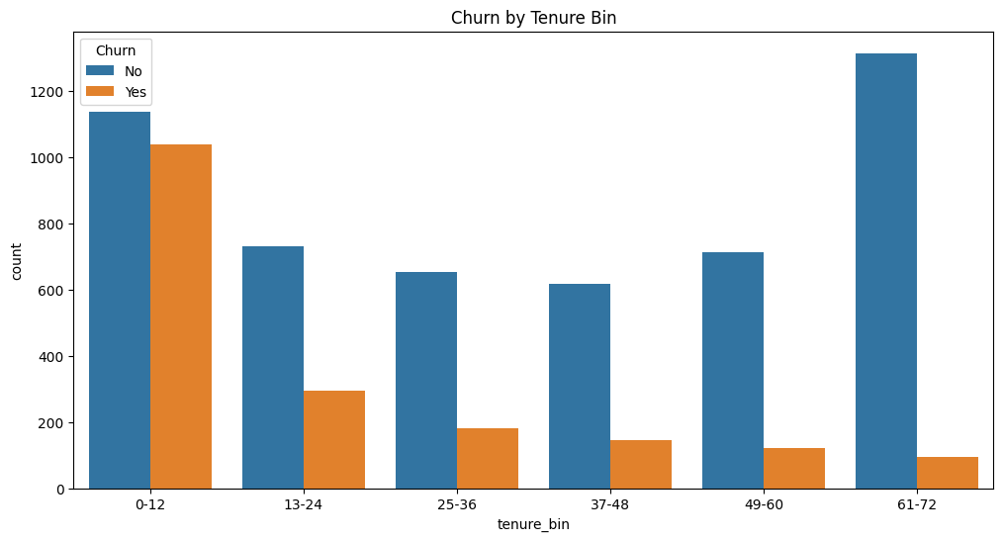
People with shorter tenure tend to churn more than others. This is because people who stayed longer may feel more loyal. People who stay for a year or less might still be testing the telecom company and might have unmet expectations leading them to leave.

    - Monthly Charges by Churn
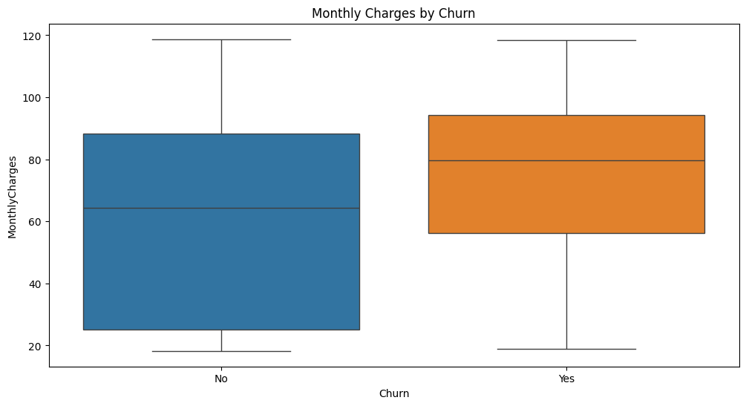
The customers who pay more monthly are at a higher risk of churn since they are concerned about cost and may feel that the value of the service doesn’t match the cost. They would be likely to cancel the service. Customers who pay less are under less pressure.

    - Churn by Internet Service
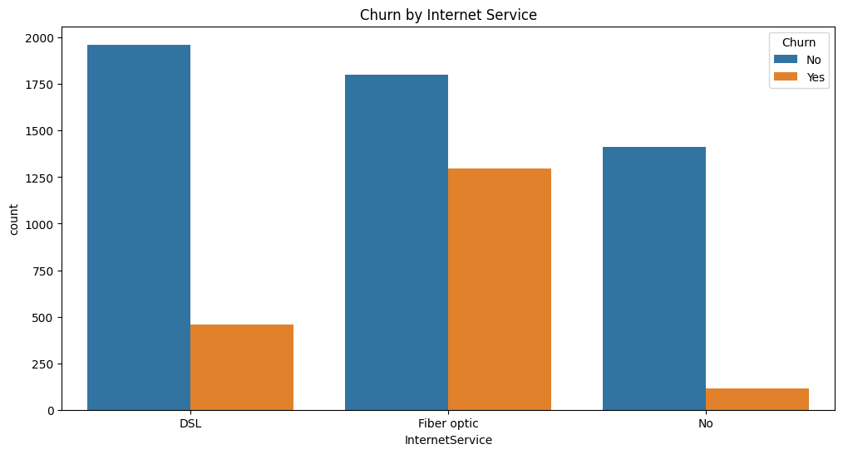
Customers paying for fiber optic are more likely to churn because fiber optic is generally pricier than DSL. For the price they pay for fiber optic, they expect faster speed and better connectivity. If they feel the service doesn’t meet their standards, they’re likely to churn.

Key Insights on Customer Churn
Based on the analysis of data, the following points discovered were:
- Customers using the monthly plans have the highest levels of churn as they do not have a commitment with a long-term contract. They’re more sensitive to price changes and any dislike they feel towards services might make them churn.
- Manual payment has a strong connection with churns compared to automatic payments. This is because when people handle payments manually, they might be more alert about what kind of prices they’re paying. They notice more details than those using auto payment.
- Customers that don't have any dependents also churn more as it shows their lack of commitments.
- Shorter tenure (most likely new customers) also plays a role in churn as they’re still building trust and adjusting to how the company works. They’re riskier because they don’t fully understand how the business operates.
- Higher monthly costs have a positive correlation with churn, making this feature important to consider when designing retention strategies. Higher costs are associated with higher chances of churn.
- Fiber optic internet leads to churn for some reason, probably due to its higher pricing.

In conclusion: Price, flexibility of the contract, manual payment methods, and customers experiences are main factors of churn.

Data Preprocessing

Data Cleaning
# drop unnecessary columns
df.drop(columns=['customerID', 'PhoneService', 'TotalCharges', 'tenure_bin'], inplace=True)
df.columns
Index(['gender', 'SeniorCitizen', 'Partner', 'Dependents', 'tenure',
'MultipleLines', 'InternetService', 'OnlineSecurity', 'OnlineBackup',
'DeviceProtection', 'TechSupport', 'StreamingTV', 'StreamingMovies',
'Contract', 'PaperlessBilling', 'PaymentMethod', 'MonthlyCharges',
'Churn'],
dtype='str')

CustomerID was dropped due to having no value for the model and merely just an identifier. PhoneService was dropped because it only contained 2 values which were Yes or No. The other column “MultipleLines” has values “No” and “No phone service” and the “no phone service” value alludes to the person not having subscribed to a phone service in the first place. So, there’s a bit of redundancy here. Someone who has no phone service to begin with, won’t have multiple lines, as opposed to someone who has a phone service but choose not to get multiple lines, hence the “No” value in MultipleLines. TotalCharges was dropped because its derived from MonthlyCharges multiplied by Tenure. Since TotalCharges is highly correlated with MonthlyCharges, it posed a risk of multicollinearity which could’ve hindered model performance. Tenure_bin is just a temporary column created for visualization purposes and serves no value to the study.

Encoding
# encode categorical variables using one-hot encoding, encode Churn using label encoding
df = pd.get_dummies(df, drop_first=True)
df['Churn'] = df['Churn_Yes']
df.drop(columns=['Churn_Yes'], inplace=True)
df.head()

# convert True and False to 1 and 0 in all columns
df = df.replace({True: 1, False: 0})
df.head()

There are many categorical features in this dataset which cannot be directly fed to the machine learning model. Therefore, these features have been converted to numbers by applying a process known as One-Hot Encoding, where there is one separate feature for each unique value in the category, and 1 means that value is true or exists. Also, the label Churn has been encoded using Label Encoding, in which case Yes is coded as 1 and No is coded as 0. The baseline was also enabled to ensure correct encoding and better usability of features in the models where redundancy is eliminated.

Correct Data Types
# change object columns to numeric
for col in df.select_dtypes(include='object').columns:
df[col] = pd.to_numeric(df[col], errors='coerce')

df.info()
<class 'pandas.DataFrame'>
RangeIndex: 7043 entries, 0 to 7042
Data columns (total 29 columns):
# Column Non-Null Count Dtype
--- ------ -------------- -----
0 SeniorCitizen 7043 non-null int64
1 tenure 7043 non-null int64
2 MonthlyCharges 7043 non-null float64
3 gender_Male 7043 non-null int64
4 Partner_Yes 7043 non-null int64
5 Dependents_Yes 7043 non-null int64
6 MultipleLines_No phone service 7043 non-null int64
7 MultipleLines_Yes 7043 non-null int64
8 InternetService_Fiber optic 7043 non-null int64
9 InternetService_No 7043 non-null int64
10 OnlineSecurity_No internet service 7043 non-null int64
11 OnlineSecurity_Yes 7043 non-null int64
12 OnlineBackup_No internet service 7043 non-null int64
13 OnlineBackup_Yes 7043 non-null int64
14 DeviceProtection_No internet service 7043 non-null int64
15 DeviceProtection_Yes 7043 non-null int64
16 TechSupport_No internet service 7043 non-null int64
17 TechSupport_Yes 7043 non-null int64
18 StreamingTV_No internet service 7043 non-null int64
19 StreamingTV_Yes 7043 non-null int64
20 StreamingMovies_No internet service 7043 non-null int64
21 StreamingMovies_Yes 7043 non-null int64
22 Contract_One year 7043 non-null int64
23 Contract_Two year 7043 non-null int64
24 PaperlessBilling_Yes 7043 non-null int64
25 PaymentMethod_Credit card (automatic) 7043 non-null int64
26 PaymentMethod_Electronic check 7043 non-null int64
27 PaymentMethod_Mailed check 7043 non-null int64
28 Churn 7043 non-null int64
dtypes: float64(1), int64(28)
memory usage: 1.6 MB

After encoding, all the features were made numeric, either by making them int64 or float64. For any remaining object columns, type conversion was used to convert them to numerical values. This is important because most machine learning models cannot process data that is not numeric.

Feature Selection by Correlation
# correlation
corr = df.corr()
corr_target = corr['Churn'].abs().sort_values(ascending=False)

# select top features
selected_features = corr_target.drop('Churn').head(10).index
selected_features
Index(['tenure', 'InternetService_Fiber optic', 'Contract_Two year',
'PaymentMethod_Electronic check', 'OnlineSecurity_No internet service',
'StreamingMovies_No internet service',
'StreamingTV_No internet service', 'TechSupport_No internet service',
'OnlineBackup_No internet service',
'DeviceProtection_No internet service'],
dtype='str')

The feature selection method used here involved correlation analysis to determine the importance of features in affecting customer churn. This process was applied through creating a correlation matrix, and ranking the absolute correlation values between each independent variable and the target variable Churn. Features that were strongly correlated were selected for use. This is helpful for improving efficiency and mitigating overfitting through feature selection.

Modeling
# define features and target
X = df[selected_features]
y = df['Churn']

from the correlation-based feature selection, X and y were chosen for models to train on.
# imbalanced data
from imblearn.over_sampling import SMOTE
from imblearn.pipeline import Pipeline

# preprocessing
from sklearn.preprocessing import StandardScaler

# models
from sklearn.linear_model import LogisticRegression
from sklearn.ensemble import RandomForestClassifier
import xgboost as xgb

# cross validation
from sklearn.model_selection import cross_val_score

Above are the imports needed to conduct prediction with cross validation across logistic regression, random forest, and XGBoost.
SMOTE was imported to handle class imbalance by generating synthetic data to oversample.
The pipeline import was included to develop a structured workflow where preprocesing and modeling are combined in one process.
Standard scaler was imported to normalize numerical features, which is important especially for logistic regression as it is sensitive to big ranges.
The models XGBoost, RF, and LR were also imported to train and evaluate, to eventually find the best ML model to predict churn in telecommunications.
And finally, cross validation was imported as a comprehensive method to train and test the entire dataset.
# pipelines
logreg_pipeline = Pipeline([
('smote', SMOTE(random_state=42)),
('scaler', StandardScaler()),
('model', LogisticRegression(max_iter=1000))
])

rf_pipeline = Pipeline([
('smote', SMOTE(random_state=42)),
('model', RandomForestClassifier(max_depth=10, min_samples_leaf=5, n_estimators=100))
])

xgb_pipeline = Pipeline([
('smote', SMOTE(random_state=42)),
('model', xgb.XGBClassifier(max_depth=10, min_child_weight=5, n_estimators=100))
])

# cross validation num of folds
cv = 5

print("LogReg:", cross_val_score(logreg_pipeline, X, y, cv=cv, scoring='accuracy').mean())
print("RF:", cross_val_score(rf_pipeline, X, y, cv=cv, scoring='accuracy').mean())
print("XGB:", cross_val_score(xgb_pipeline, X, y, cv=cv, scoring='accuracy').mean())

LogReg: 0.7298024267694689
RF: 0.7298012170140009
XGB: 0.7229862612104008

Three pipelines were created for each model. Within each pipeline, SMOTE is included to handle the imbalance. For logistic regression’s pipeline, standard scaler is also included. As for RF and XGB, they don’t need the scaler due to their nature of using decision trees that arent sensitive to big ranges. With pipelines, steps like oversampling and modeling are bundled together in the correct order. Pipelines ensure efficiency and consistency for cross validation to properly work.
Next, cross validation was applied to each model with 5 folds. Then, each model’s pipeline was included for training. Features and target were also provided, cv score was set as 5 folds, the main evaluation method here was accuracy because it’s the most simple and standard metric. Then finally, all accuracies produced by each fold were averaged and results were produced.
In terms of model performance using cv, logistic regression and random forest are almost identical, going neck-to-neck with 0.729802 for LR and 0.729801 for RF. XGB gave the “lowest” performance though all models are very similar. Both Logistic Regression and Random Forest had basically the same results in cross validation, showing equal performance. But, while Logistic Regression had a slightly higher cross validation result, Random Forest had slightly higher accuracy and F1 score. So, Random Forest model will be chosen as the best performer.

Models Evaluation
from sklearn.model_selection import cross_validate

scoring = ['accuracy', 'precision_weighted', 'recall_weighted', 'f1_weighted']
cv = 5

# Logistic Regression
logreg_results = cross_validate(logreg_pipeline, X, y, cv=cv, scoring=scoring)

# Random Forest
rf_results = cross_validate(rf_pipeline, X, y, cv=cv, scoring=scoring)

# XGBoost
xgb_results = cross_validate(xgb_pipeline, X, y, cv=cv, scoring=scoring)

# print results
print(f"""
Logistic Regression:
Accuracy : {logreg_results['test_accuracy'].mean():.4f}
Precision: {logreg_results['test_precision_weighted'].mean():.4f}
Recall : {logreg_results['test_recall_weighted'].mean():.4f}
F1 Score : {logreg_results['test_f1_weighted'].mean():.4f}

Random Forest:
Accuracy : {rf_results['test_accuracy'].mean():.4f}
Precision: {rf_results['test_precision_weighted'].mean():.4f}
Recall : {rf_results['test_recall_weighted'].mean():.4f}
F1 Score : {rf_results['test_f1_weighted'].mean():.4f}

XGBoost:
Accuracy : {xgb_results['test_accuracy'].mean():.4f}
Precision: {xgb_results['test_precision_weighted'].mean():.4f}
Recall : {xgb_results['test_recall_weighted'].mean():.4f}
F1 Score : {xgb_results['test_f1_weighted'].mean():.4f}
""")

Logistic Regression:
Accuracy : 0.7298
Precision: 0.7965
Recall : 0.7298
F1 Score : 0.7446

Random Forest:
Accuracy : 0.7304
Precision: 0.7920
Recall : 0.7304
F1 Score : 0.7448

XGBoost:
Accuracy : 0.7230
Precision: 0.7862
Recall : 0.7230
F1 Score : 0.7379

The three models performed equally well, having an accuracy of around 73%. Random Forest performed the best among the other two models, giving a higher accuracy of 0.7304 and F1 Score of 0.7448. Logistic Regression performed the best in terms of precision, showing high efficiency of correctly predicting the churners. However, recall was generally moderate for the three models, meaning that there were some churners that were not being captured. This could have resulted from data imbalances in the dataset.
from sklearn.model_selection import cross_val_predict
from sklearn.metrics import confusion_matrix

# predictions using cross validation
y_pred_logreg = cross_val_predict(logreg_pipeline, X, y, cv=cv)
y_pred_rf = cross_val_predict(rf_pipeline, X, y, cv=cv)
y_pred_xgb = cross_val_predict(xgb_pipeline, X, y, cv=cv)

# confusion matrix
conf_matrix_logreg = confusion_matrix(y, y_pred_logreg)
conf_matrix_rf = confusion_matrix(y, y_pred_rf)
conf_matrix_xgb = confusion_matrix(y, y_pred_xgb)

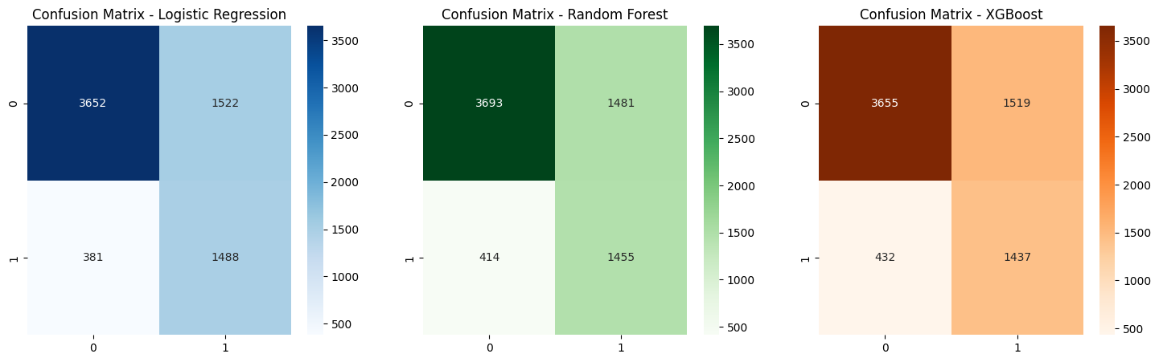
From the confusion matrix results, it is clear that all the models have a similar performance pattern, although there are some differences. Random Forest is able to detect the most number of non-churners, it also has the minimum number of false positives, which is slightly improving its accuracy. However, logistic regression is more effective in predicting churners, due to its minimum number of FN, meaning that it detects fewer customers who might churn. Finally, XGB has a lower performance, as it has the highest number of FN.

Feature Importance
# fit models on full dataset after cv
logreg_pipeline.fit(X, y)
rf_pipeline.fit(X, y)
xgb_pipeline.fit(X, y)

logreg_model, rf_model, xgb_model_final = (
logreg_pipeline['model'],
rf_pipeline['model'],
xgb_pipeline['model']
)

# feature importance
feature_importance_rf = rf_model.feature_importances_
feature_importance_xgb = xgb_model_final.feature_importances_
feature_importance_logreg = np.abs(logreg_model.coef_[0])

feature_names = X.columns

# dataframe
feature_importance_df = pd.DataFrame({
'Feature': feature_names,
'Random Forest Importance': feature_importance_rf,
'XGBoost Importance': feature_importance_xgb,
'Logistic Regression Importance': feature_importance_logreg
})

feature_importance_df.set_index('Feature', inplace=True)

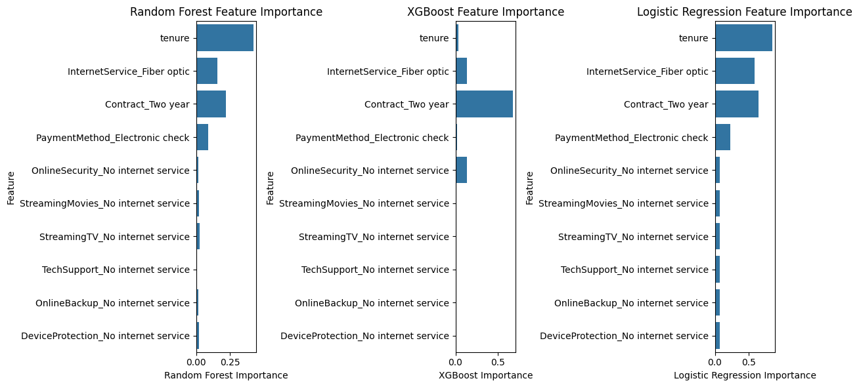
The chart above compares feature importance across the models. We can see that tenure turns out to be the most important feature for all three models as tenure has a significant influence on whether a customer will churn. The customers having a smaller tenure are more prone to churn. Features like Internet service (fiber optic) and contract (two year) are also important factors as well for churn prediction as fiber optic tends to be more expensive and people who stay for years also influence that decision. However, features associated with no internet service such as streaming TV and online security became less significant, possibly because they have little influence on the decision-making process of the model.

ROC AUC Curve
# roc and auc curves for each model
from sklearn.metrics import roc_curve, auc
y_prob_logreg = cross_val_predict(logreg_pipeline, X, y, cv=cv, method='predict_proba')[:, 1]
y_prob_rf = cross_val_predict(rf_pipeline, X, y, cv=cv, method='predict_proba')[:, 1]
y_prob_xgb = cross_val_predict(xgb_pipeline, X, y, cv=cv, method='predict_proba')[:, 1]
# plot roc curve for each model
fpr_logreg, tpr_logreg, _ = roc_curve(y, y_prob_logreg)
fpr_rf, tpr_rf, _ = roc_curve(y, y_prob_rf)
fpr_xgb, tpr_xgb, _ = roc_curve(y, y_prob_xgb)
# display roc curve
plt.figure(figsize=(8, 6))
plt.plot(fpr_logreg, tpr_logreg, label=f'Logistic Regression (AUC = {auc(fpr_logreg, tpr_logreg):.4f})')
plt.plot(fpr_rf, tpr_rf, label=f'Random Forest (AUC = {auc(fpr_rf, tpr_rf):.4f})')
plt.plot(fpr_xgb, tpr_xgb, label=f'XGBoost (AUC = {auc(fpr_xgb, tpr_xgb):.4f})')
plt.title('ROC Curve')
plt.xlabel('False Positive Rate')
plt.ylabel('True Positive Rate')
plt.legend()
plt.show()
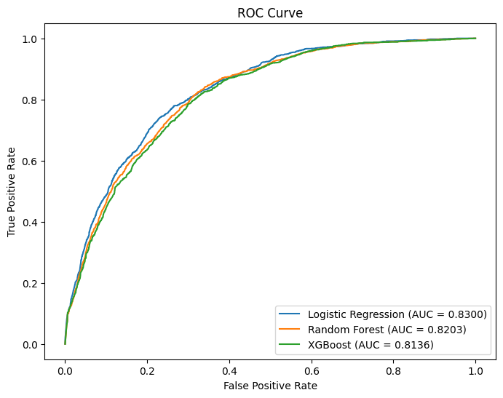
The ROC AUC curve is used to show how well a model can diffrenciate between classes churn and non-churn. The ROC curve shows the TP and the FP rate with different thresholds. The AUC shows percentage of correctly differentiating between churn and non churn classes. In this project, all three models performed well, with AUC values above 0.80. Meaning they’re good at classification. The logistic Regression achieved the highest AUC of 0.8300, then Random Forest got 0.8203 and finally XGBoost got 0.8136. The curves are very close to each other, showing that all models have similar performance. Logistic Regression slightly outperforms the others in diffrenciating between churners and non-churners.

Churn Prediction Results

Best Model
After analyzing the models, Logistic Regression and Random Forest are nearly the same both on cross validation and evaluation metrics. Cross validation results are nearly equal (0.7298 for Logistic Regression and 0.7298 for Random Forest), meaning that generalization of the models are basically identical.
Also, when reviewing the models' accuracy and F1 scores, Random Forest performs slightly better than Logistic Regression (accuracy is 0.7304, and F1 score is 0.7448). However, Logistic Regression has a higher precision (0.7965), but the difference is insignificant. XGBoost model performs worse than Logistic Regression and Random Forest. So, the best model would be Random Forest because it has the best performance metrics out of the rest.
Small differences in the accuracy on cross validation and evaluation are normal and are caused by SMOTE in the pipeline. Due to randomness in the sampling process, the fact that SMOTE produces different synthetic data per fold, and the method used for scoring and averaging, there is a small difference in the results. As cross_val_score only calculates accuracy, while cross_validate calculates multiple metrics at once.
In terms of ROC AUC, logistic regression outperformed the others. Random forest came in second. While evaluating ROC AUC is important, the decision to pick the best model was based on the overall performance. In terms of overall performance, random forest appears to have the top metrics. So, random forest wins.

Conclusion

Summary of Findings
From this project, it becomes clear that in telecom services, factors such as tenure, contract type, monthly charges, and payment methods influence the probability of customers switching service providers. Customers who have stayed with the company for a shorter period, and have high monthly expenses, and pay for a monthly contract have a higher likelihood to churn. The findings from the machine learning models support the claims, and Random Forest was the top performer in terms of cross validation and generalization abilities, but only barely. It technically has higher metrics, but logistic regression is just as good in practice. Telecom companies should invest in machine learning algorithms to save customer acquisition costs and develop decision support systems that use machine learning to help them take proactive measures.

Recommendations for Reducing Churn
To keep more clients, telecom companies need to come up with ways of maintaining these clients. For instance:
Customers with monthly plans are more likely to churn. The telecom company can offer discounts/rewards to convince customers to enter a contract plan for either one year or two years.
The customers who pay with non-automatic payment methods, such as electronic checks, have a higher churn rate. marketing auto-payments from credit cards or direct debits from banks can be helpful for customer retention.
Customers having low tenure show a higher churn rate. To retain these customers, some loyalty program or discount can be offered at the start of the relationship period, to strengthen loyalty and trust.
The monthly charge plays an important role in the churn. Higher monthly charges imply higher churn. Companies can consider offering flexible pricing plans.
Higher churn is experienced by fiber optic customers, possibly due to high expectations. The telecom company must ensure fiber optic is delivered with the highest quality.
Customers with no commitments tend to churn more. The telecom company should create targeted marketing campaigns to different demographics; students with no dependents have more freedom to explore other options than people with families.

Limitations
Even though the models produced decent results, the limitations should be pointed out. Firstly, the imbalance in the dataset plays a role, and SMOTE’s method in generating synthetic customers doesn’t always represent realistic behavior. Second, feature selection was done with correlation, and that doesn’t mean causation. This might diminish the complexity of relationships between features. The number of folds could’ve played a role in the performance Lastly, we only tested 3 models, but other more advanced models may produce better results.

Future Improvements
In terms of the future improvements for this project, the use of more complex machine learning methods could be helpful. For example, we might want to use the method of deep learning and hyperparameter tuning. Furthermore, adjusting the number of cross-validation folds to test our predictions would help us find out whether they can be considered valid or not. We could’ve also binned payment types to “manual” and “automatic” for simplicity. There also could’ve been a feature showing the total number of services a customer is paying for, to show that more subscriptions lead to lower churn. We could’ve combined partner and dependents into 1 feature named family members because familial responsibilities lead to more stability with the company as shown earlier.

References

Boddepalli, D. (2024). Churn prediction in telecommunication using deep learning techniques. International Journal of Research Publication and Reviews, 5(11), 7776–7780. https://ijrpr.com/uploads/V5ISSUE11/IJRPR35753.pdf

Nie, G., Rowe, W., Zhang, L., Tian, Y., & Shi, Y. (2011). Credit card churn forecasting by logistic regression and decision tree. Expert Systems with Applications, 38(12), 15273–15285. https://doi.org/10.1016/j.eswa.2011.06.028

Sam, G., Asuquo, P., & Stephen, B. (2024). Customer churn prediction using machine learning models. Journal of Engineering Research and Reports, 26(2), 181–193. https://doi.org/10.9734/jerr/2024/v26i21081

Chen, X., Lv, B., Wang, M., Xiang, X., Wu, S., Luo, S., & Zhang, W. (2025). A Comprehensive Analysis of Churn Prediction in Telecommunications Using Machine Learning. ArXiv.org. https://arxiv.org/abs/2509.22654

Krishna, R., D. Jayanthi, Sam, D. S. Shylu., K. Kavitha, Naveen Kumar Maurya, & T. Benil. (2024). Application of Machine Learning Techniques for Churn Prediction in The Telecom Business. Results in Engineering, 103165–103165. https://doi.org/10.1016/j.rineng.2024.103165

Ribeiro, H., Barbosa, B., Moreira, A. C., & Rodrigues, R. (2024). Customer Experience, Loyalty, and Churn in Bundled Telecommunications Services. SAGE Open, 14(2).

Kaggle. (2017). Telco Customer Churn. Www.kaggle.com. https://www.kaggle.com/datasets/blastchar/telco-customer-churn

